CEE-205 Final Test

WRITE YOUR NAME HERE: __________Aidan Foss_______________________

Due: Friday, May 5th, 2023

1. True/False. If false, correct the statement (4.5 pts, 1.5pt/each):
a. Ammeter must be placed in parallel series with the element whose current is to be measured. _________FALSE____________

b. A circuit element with resistance approaching zero is called a short circuit. an open circuit. __FALSE__

c. The superposition principle states that the total response is the sum of the responses to each of the independent sources acting individually. ____TRUE_______

2. (2.5 pts) Answer the following question.
An inductor of value 0.5 henry is used in a circuit driven by a source:
v(t)=V_{m} ·cos (200t). The impedance of the inductor is ( A, j(50/pi) )

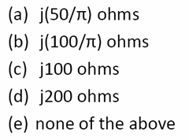

3. (15 pts) Find the voltage provided by the voltage source V_{S}=? in the following circuit.
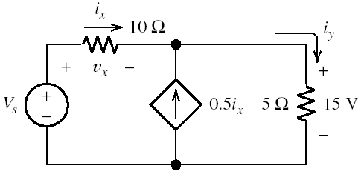
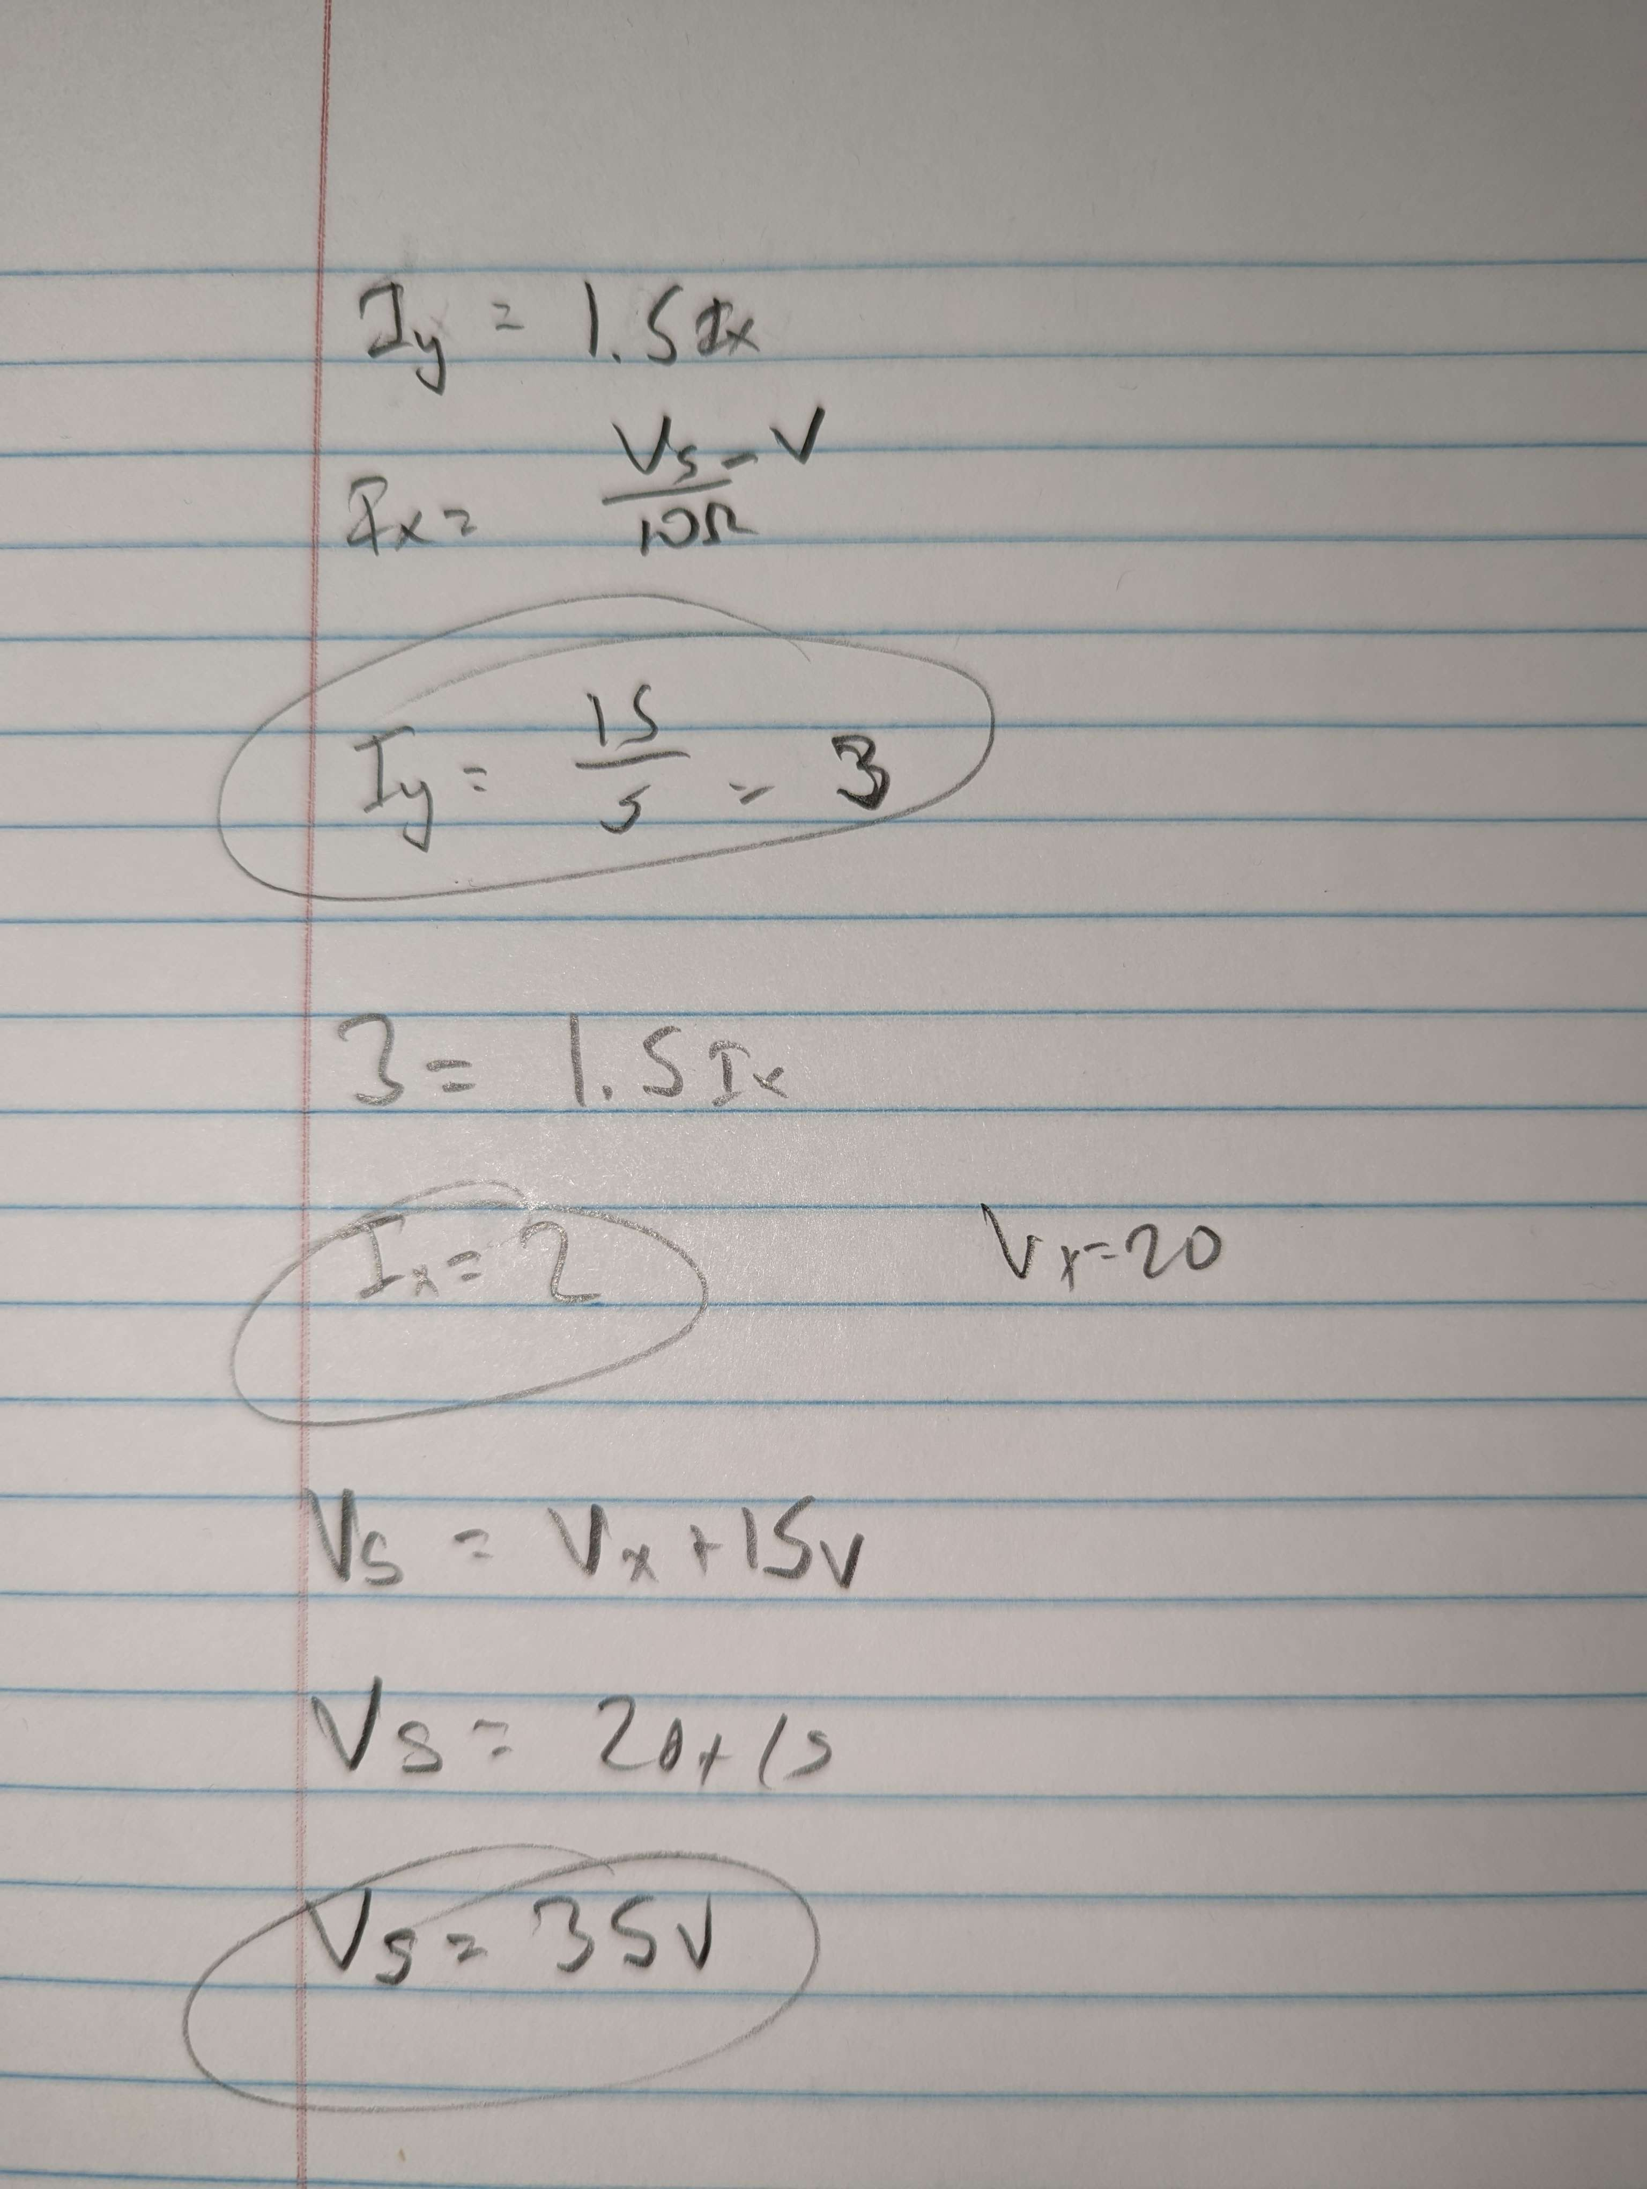
Ohms law and KCL

4. (15 pts) Using node voltage analysis, find the voltages V₁ and V₂ for the following circuit.
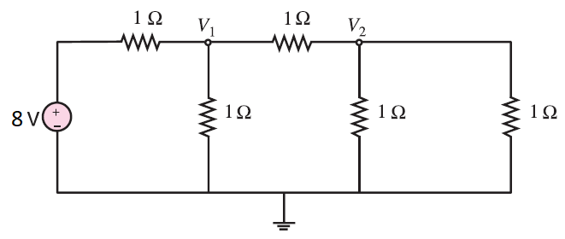
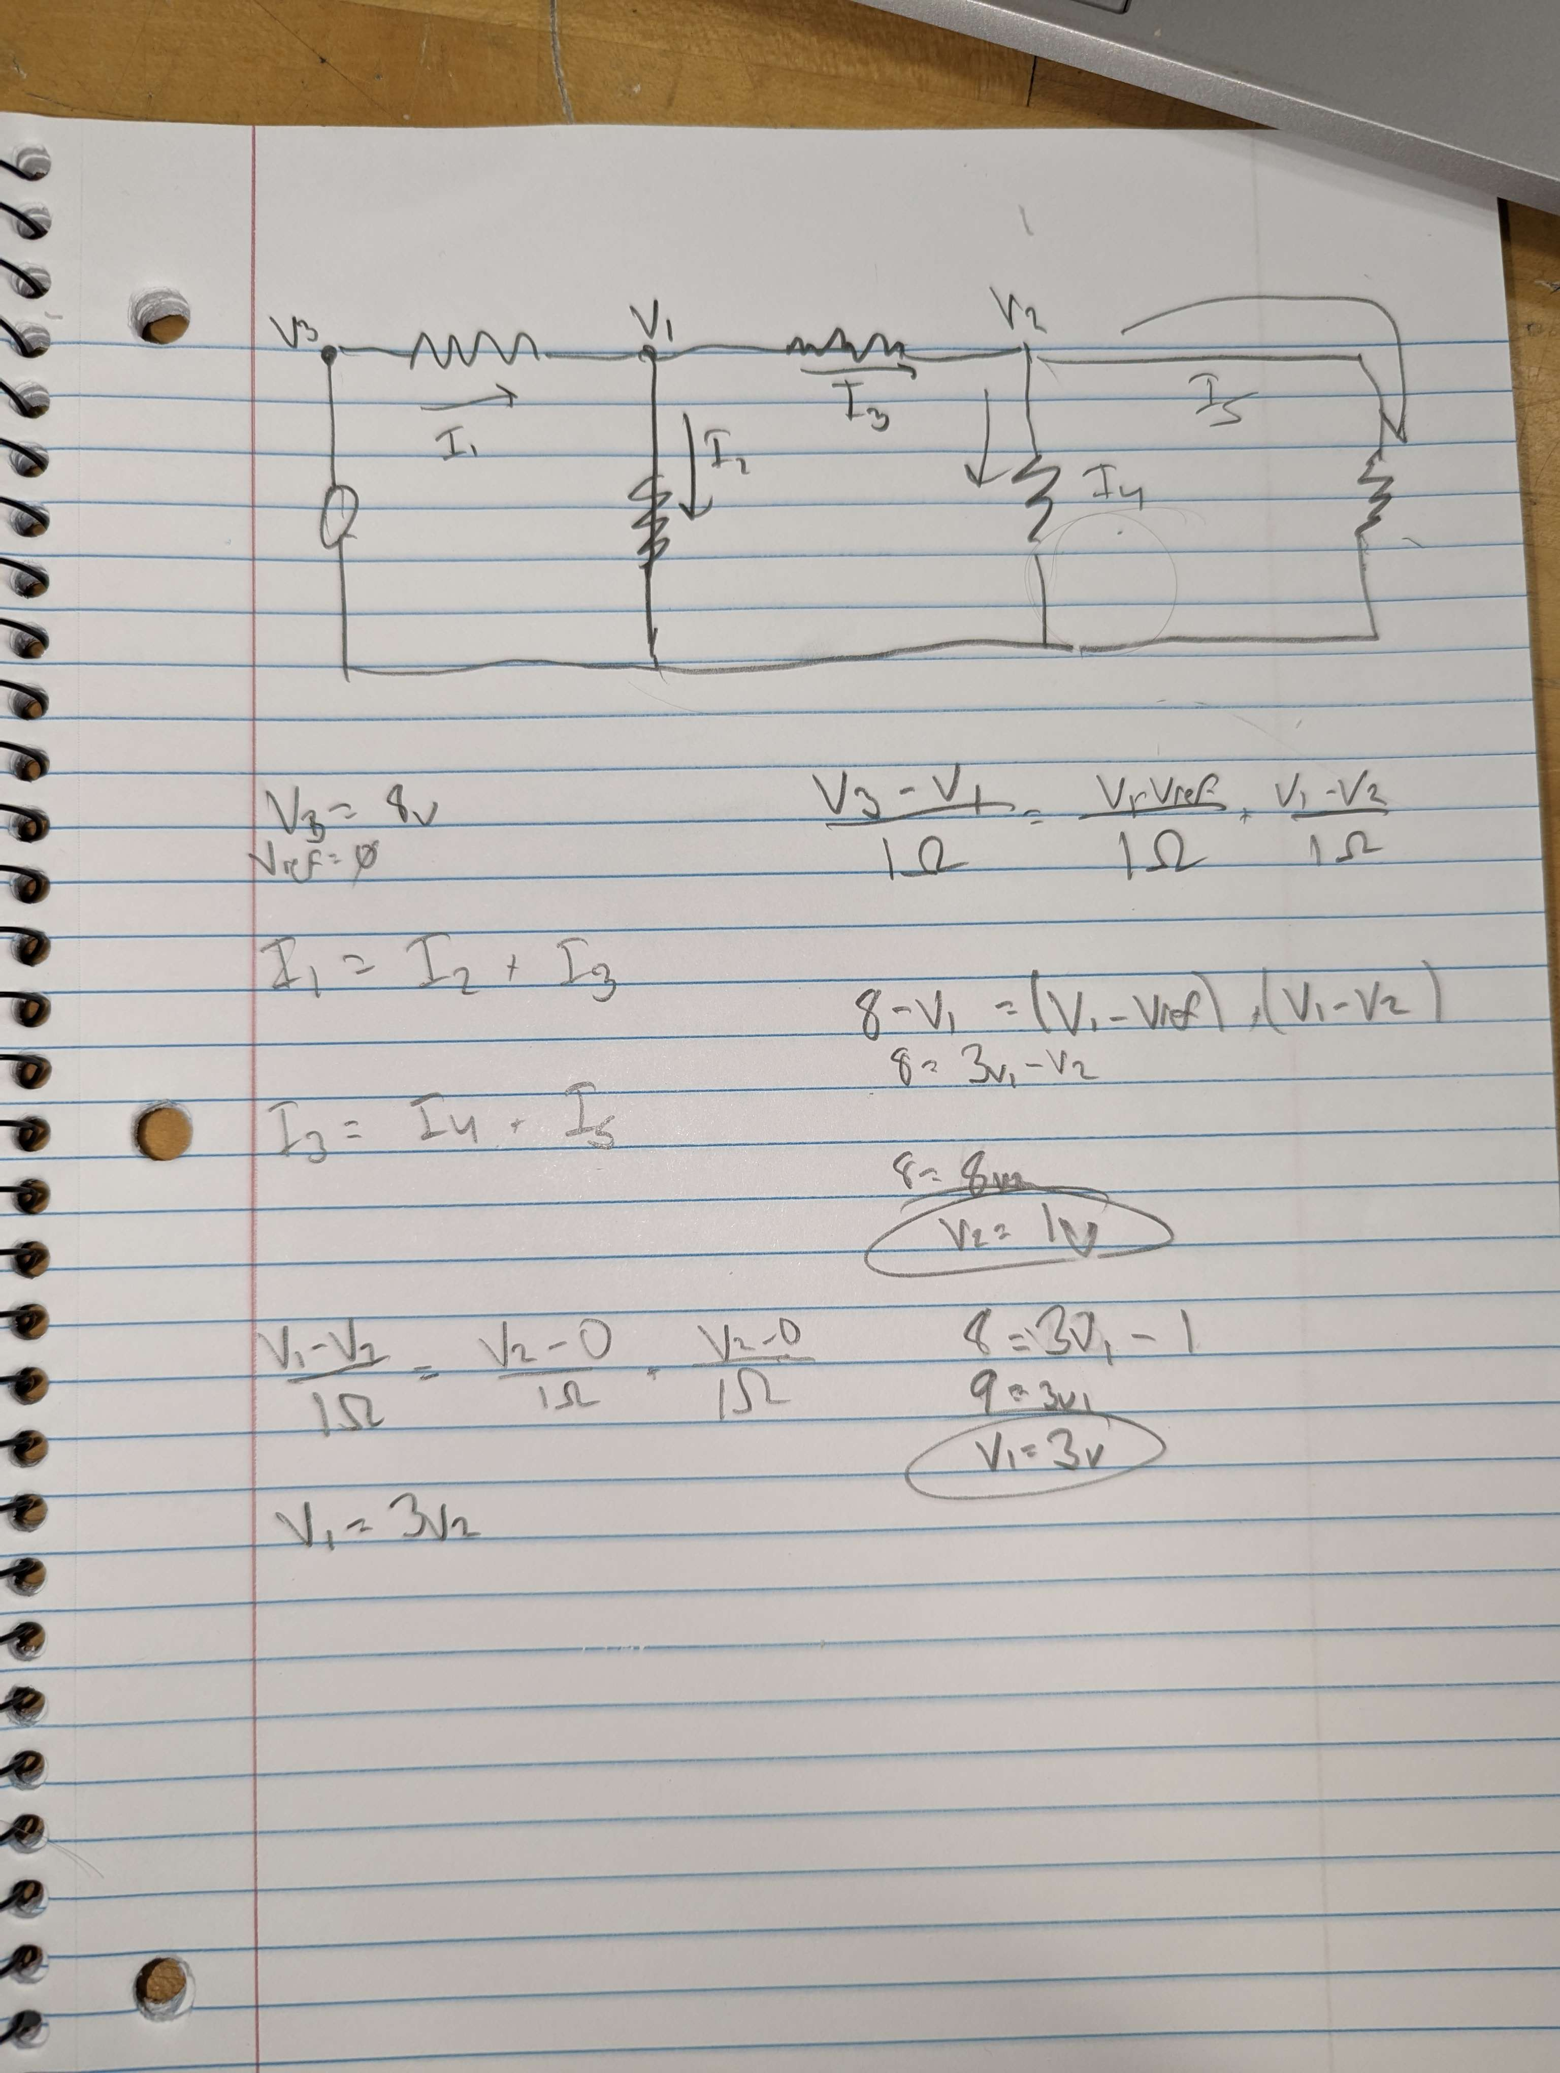

5. (13 pts) The resistor and capacitor have a capacitance of 40mF and a resistance of 5Ω connected to a 15V DC voltage source.
a) What is the initial value of the current at the moment the switch is closed t=0?
b) What is the time constant of the circuit?
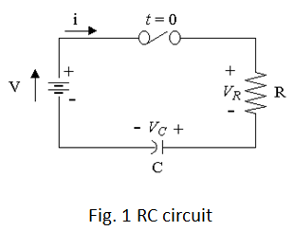
c) What is the value of the voltage across V_{C} after 100ms?

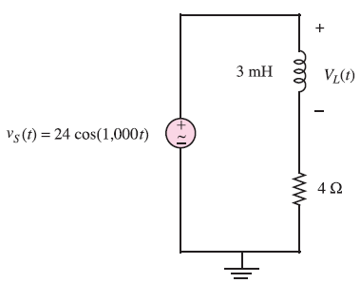
6. (15 pts) Determine the voltage across the inductor in the following circuit.

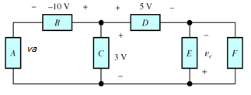
7. (10 pts) Calculate V_{a}, V_{e}, and V_{f} in the circuit below. Mark the polarity for all voltages in the circuit.

8. (10 pts) Design a summing amplifier as shown in figure to produce a specific output signal, such that v_{o} = -5 volt. Assume the input signals are v_{I1} = 1.0 volt, v_{I2} = 1.0 volt, R1 = R2. Assume the feedback resistance R_{F} = 10 kΩ.
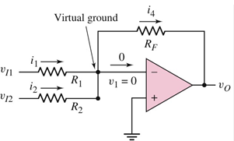

9. (15 pts) Determine Voltage V_{R1} in the circuit, using Superposition principle:
V₁ = 12 V, V₂ = 5 V, R₁ = R₂ = R₃ = 1 kΩ.
